Crossed Triangle
# Source: AI Source: Provided by: [Data Path: Persons Table -> ID Column: 1, Name_En Column: Motasem Essam] -> From: [ChatGPT] on [7/25/2026]
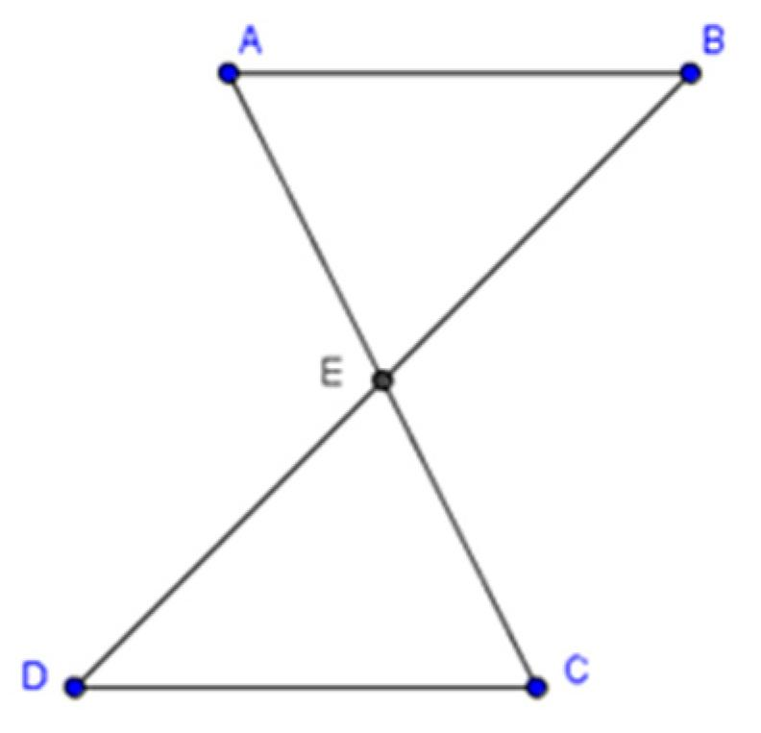
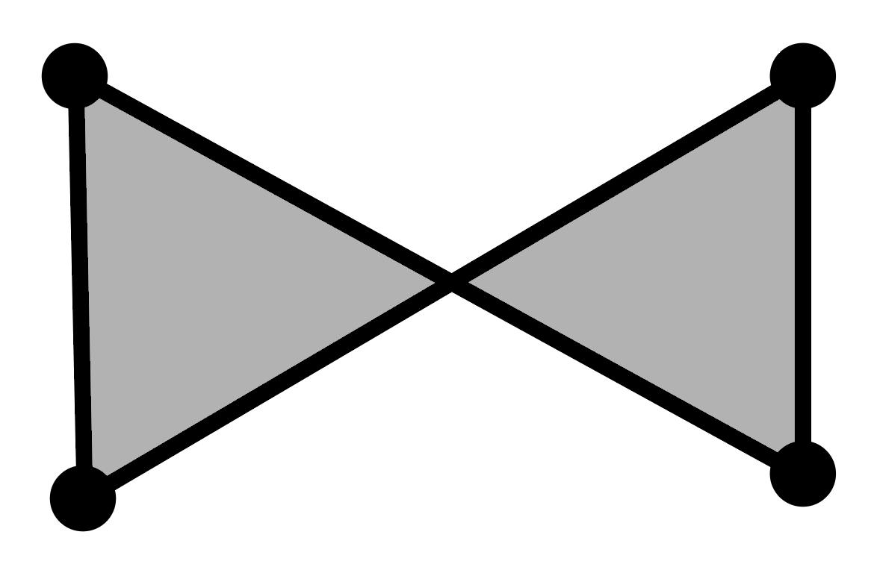
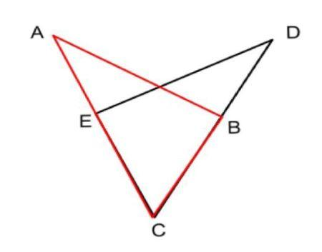
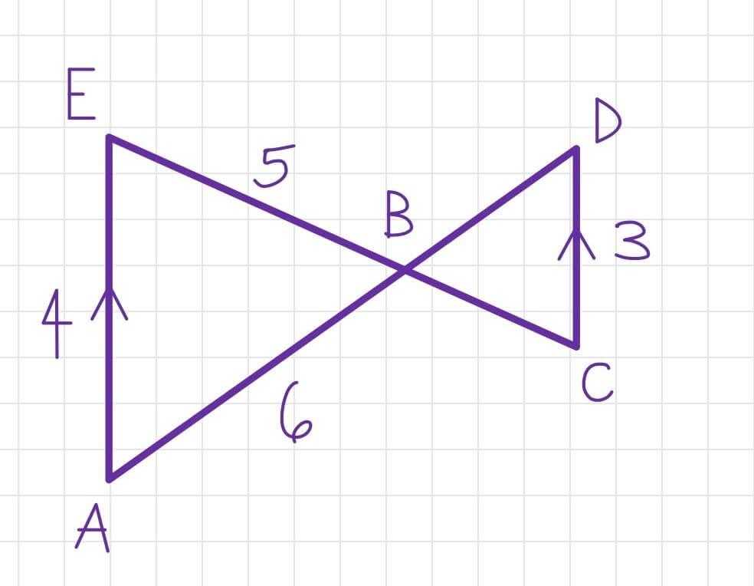

Definition
# Source: AI Source: Provided by: [Data Path: Persons Table -> ID Column: 1, Name_En Column: Motasem Essam] -> From: [ChatGPT] on [7/25/2026]
A crossed triangle is a triangle-like configuration in which one or more of its sides cross each other, creating a self-intersecting boundary.
However, there is an important geometric distinction:
In standard Euclidean geometry, a triangle is a simple polygon, so its three sides cannot cross except at their shared endpoints.
Therefore, a crossed triangle is not a conventional simple triangle. It is better treated as a self-intersecting or crossed three-edge polygonal configuration.

Fundamental Concept
# Source: AI Source: Provided by: [Data Path: Persons Table -> ID Column: 1, Name_En Column: Motasem Essam] -> From: [ChatGPT] on [7/25/2026]
A standard triangle has three vertices:
$$A, B, C$$
and three sides:
$$\overset{‾}{AB}, \overset{‾}{BC}, \overset{‾}{CA}$$
The sides meet only at their corresponding vertices.
A crossed configuration occurs when the edges are arranged so that two non-adjacent edges intersect at a point other than a common vertex.
For example:
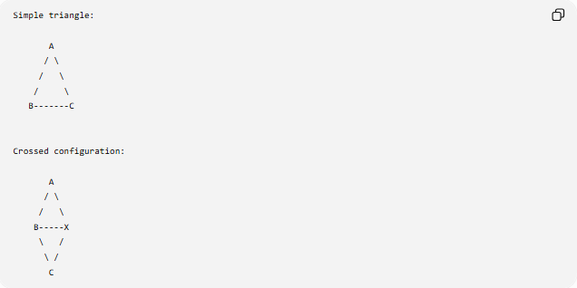
Simple triangle:

A
/ \
/ \
/ \
B-------C

Crossed configuration:

A
/ \
/ \
B-----X
\ /
\ /
C
The exact appearance depends on the ordering of the vertices and edges.

Why Crossed Triangles Are Special
# Source: AI Source: Provided by: [Data Path: Persons Table -> ID Column: 1, Name_En Column: Motasem Essam] -> From: [ChatGPT] on [7/25/2026]
For a triangle, every pair of sides normally shares a vertex:
$$AB∩BC=\left\{B\right\} \\ BC∩CA=\left\{C\right\} \\ CA∩AB=\left\{A\right\}$$
Thus, there is no pair of non-adjacent sides available to cross.
This means that a genuine self-intersection cannot occur in an ordinary 3-sided polygon while preserving the usual polygon definition.
Therefore:
$$\boxed{\text{A standard triangle cannot be a self-intersecting polygon.}}$$

Crossed Triangle-Like Shapes
# Source: AI Source: Provided by: [Data Path: Persons Table -> ID Column: 1, Name_En Column: Motasem Essam] -> From: [ChatGPT] on [7/25/2026]
What is sometimes informally called a crossed triangle may instead be a crossed shape composed of three line segments or rays whose arrangement resembles a triangle but does not satisfy the formal definition of a triangle.
Such a configuration can involve:
- Crossing line segments
- Overlapping segments
- Multiple intersection points
- A non-simple boundary
- Regions that are not bounded in the same way as a triangle
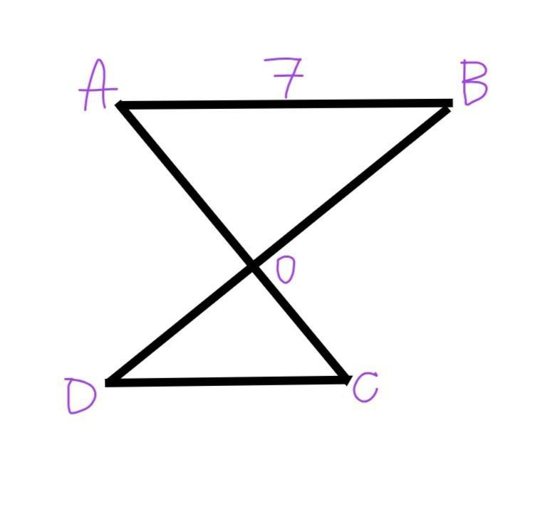
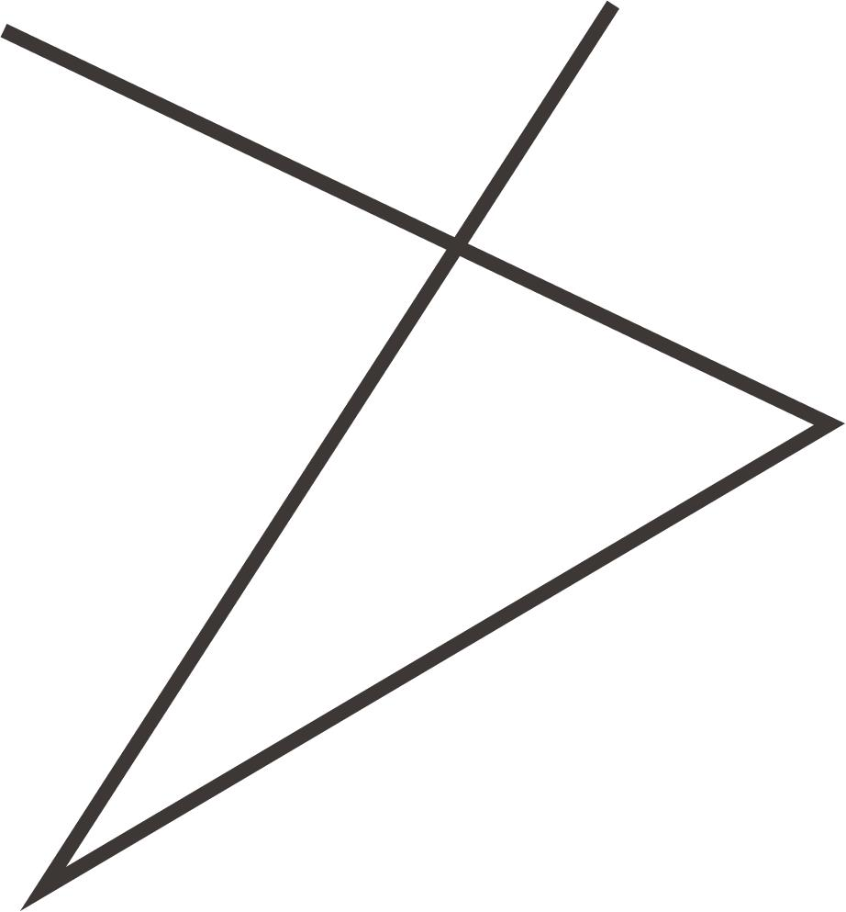
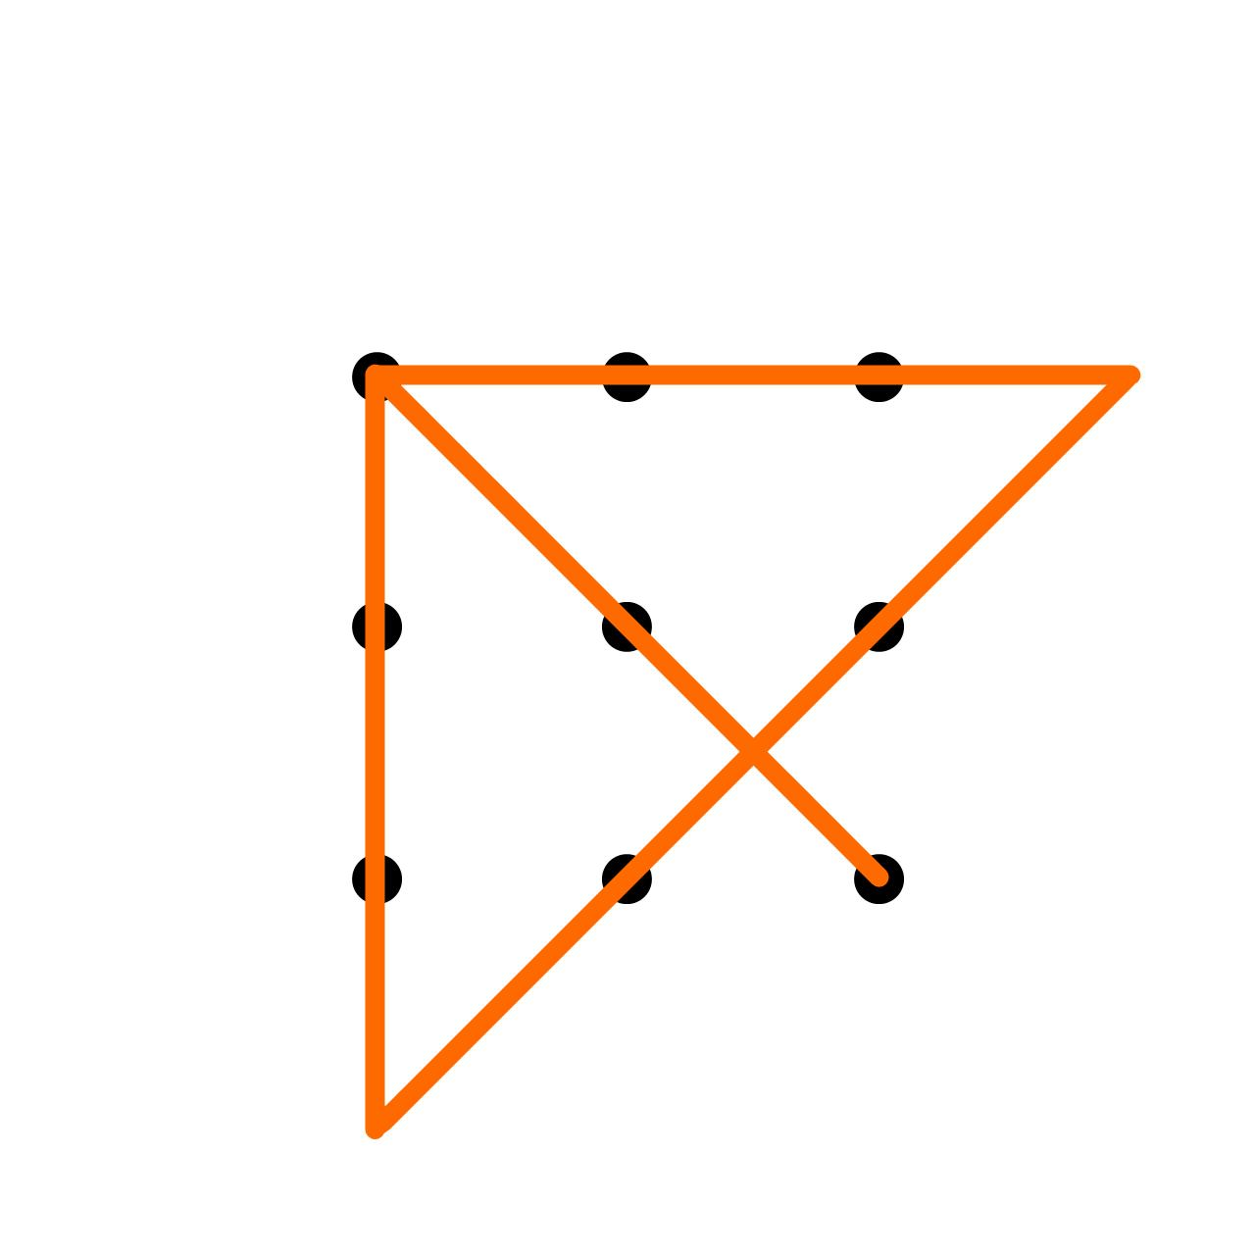

Crossed vs. Ordinary Triangle
# Source: AI Source: Provided by: [Data Path: Persons Table -> ID Column: 1, Name_En Column: Motasem Essam] -> From: [ChatGPT] on [7/25/2026]
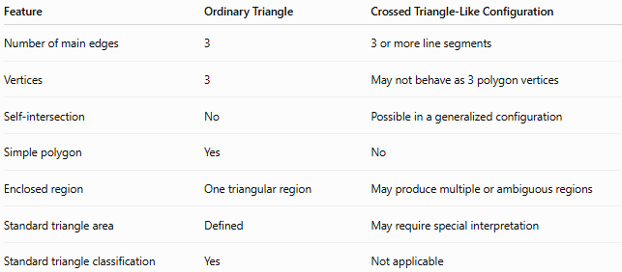
Feature | Ordinary Triangle | Crossed Triangle-Like Configuration
Number of main edges | 3 | 3 or more line segments
Vertices | 3 | May not behave as 3 polygon vertices
Self-intersection | No | Possible in a generalized configuration
Simple polygon | Yes | No
Enclosed region | One triangular region | May produce multiple or ambiguous regions
Standard triangle area | Defined | May require special interpretation
Standard triangle classification | Yes | Not applicable

Relationship to Self-Intersecting Polygons
# Source: AI Source: Provided by: [Data Path: Persons Table -> ID Column: 1, Name_En Column: Motasem Essam] -> From: [ChatGPT] on [7/25/2026]
A self-intersecting polygon has at least two non-adjacent edges that intersect.
For an $n$-gon, this is possible when:
$$n≥4$$
because a triangle has no pair of non-adjacent edges.
The simplest familiar self-intersecting polygon is the crossed quadrilateral, often called a bow-tie quadrilateral.
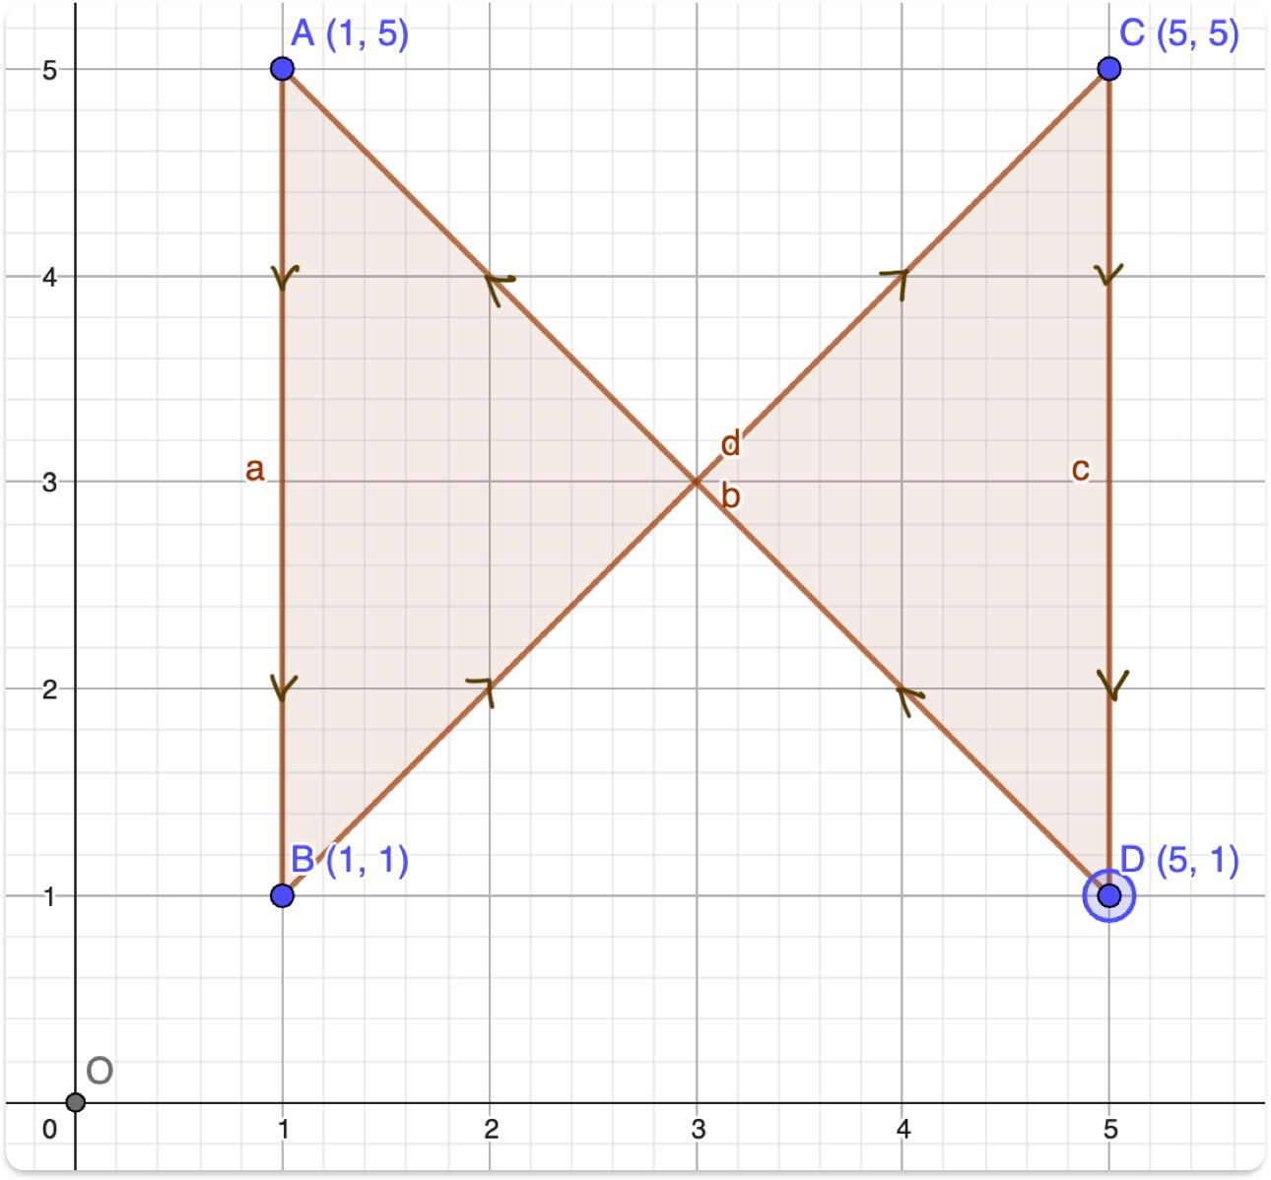
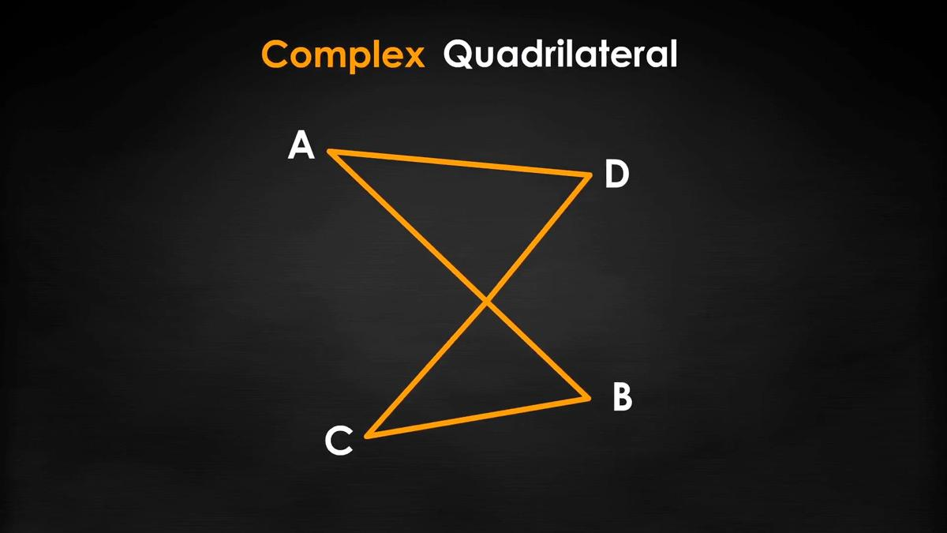
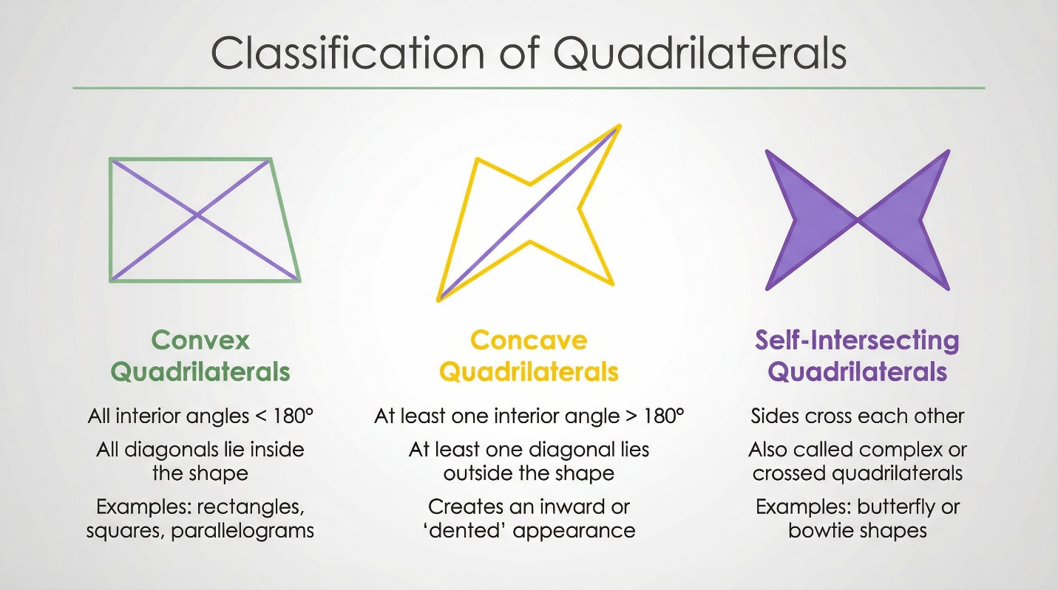
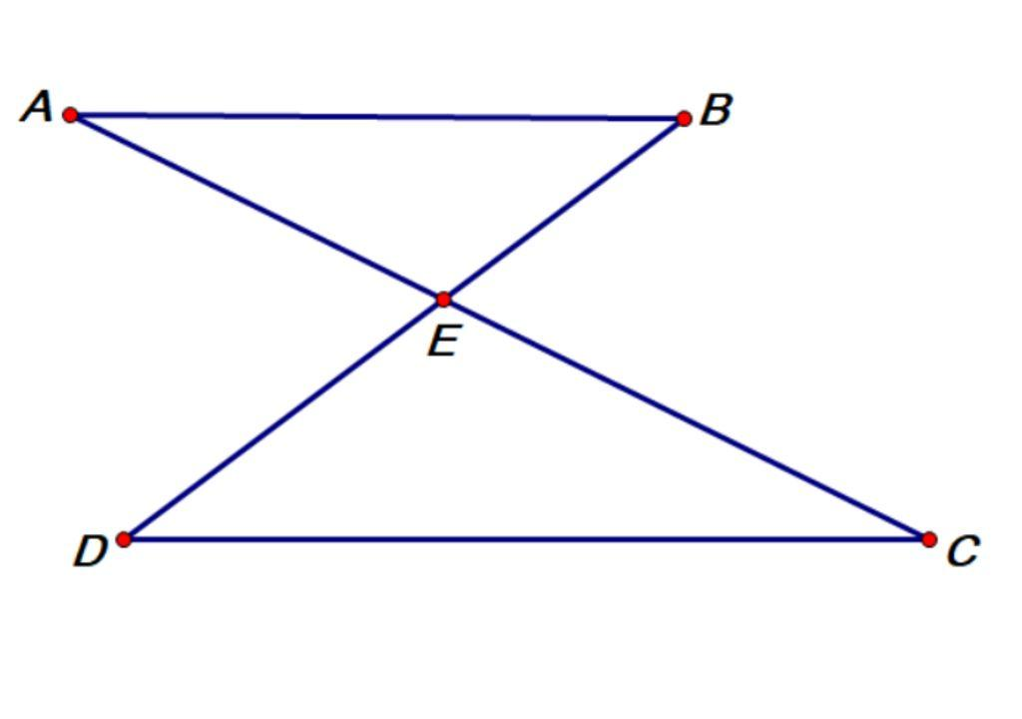
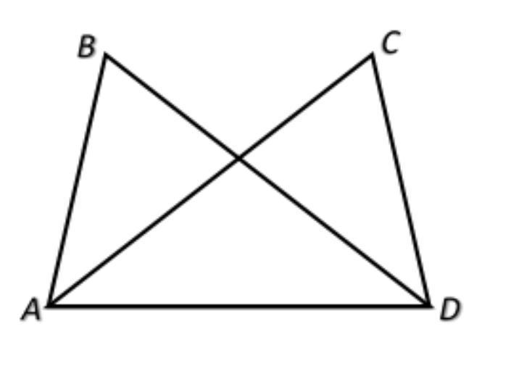

Important Distinction
# Source: AI Source: Provided by: [Data Path: Persons Table -> ID Column: 1, Name_En Column: Motasem Essam] -> From: [ChatGPT] on [7/25/2026]
Do not confuse crossed triangles with two overlapping triangles.
Two overlapping triangles
Two separate triangles may intersect:
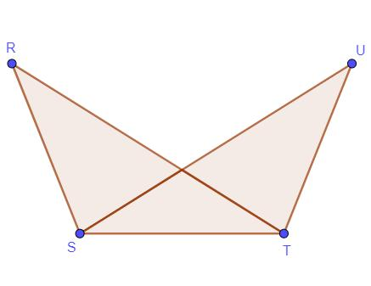
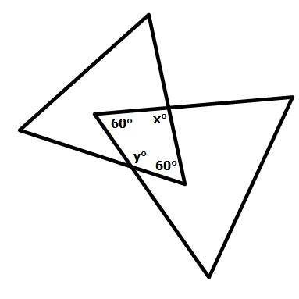
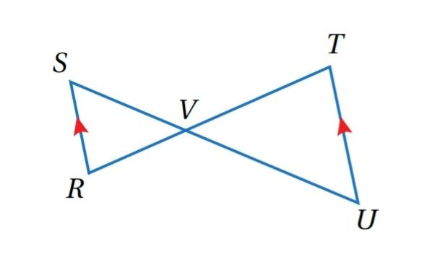
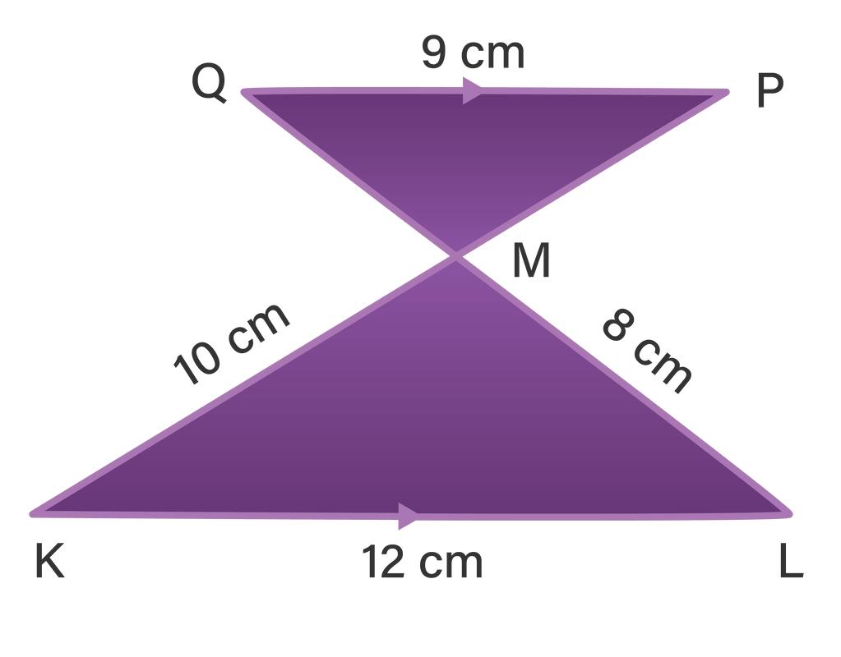
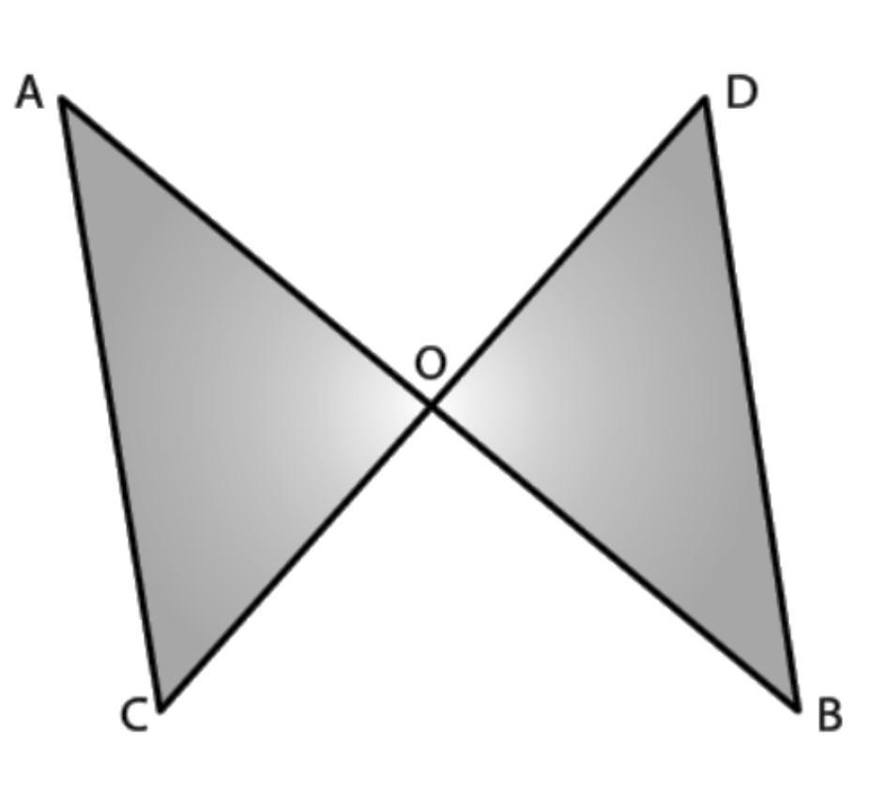
Here, each individual triangle remains a valid triangle. Their boundaries or regions intersect, but neither triangle necessarily becomes a crossed triangle.
Crossed configuration
A crossed configuration refers to self-intersection within the boundary itself.

Key Points
# Source: AI Source: Provided by: [Data Path: Persons Table -> ID Column: 1, Name_En Column: Motasem Essam] -> From: [ChatGPT] on [7/25/2026]
- A standard triangle is a simple polygon.
- Its three sides cannot cross except at their shared vertices.
- Therefore, a formally defined self-intersecting triangle does not exist in ordinary polygon geometry.
- “Crossed triangle” can be used informally for a triangle-like crossed arrangement of segments.
- For a formal taxonomy, crossed configurations are better associated with self-intersecting polygons or intersecting line segments.
- The simplest standard crossed polygon is a crossed quadrilateral.

Conclusion
# Source: AI Source: Provided by: [Data Path: Persons Table -> ID Column: 1, Name_En Column: Motasem Essam] -> From: [ChatGPT] on [7/25/2026]
Crossed Triangle is not a standard mathematical type of triangle. Because every pair of triangle sides is adjacent and shares a vertex, a triangle cannot have the self-intersection characteristic of a crossed polygon. For a structured geometry taxonomy, it is therefore more accurate to classify crossed configurations under Self-Intersecting/Crossed Polygons or Intersection, rather than under the standard Triangles classification.s

